|  |  |  |
| --- | --- | --- |
|  | **Food Quality Monitoring System**  **Using Arduino Uno** |  |

**19EEPN6401– MINIPROJECT**

**Submitted by**

|  |  |
| --- | --- |
| **SARAN K V** | **21BEE312** |

***In partial fulfillment for the award of the*** ***degree of***

**BACHELOR OF ENGINEERING**

**in**

**Electrical and Electronics Engineering**

**Dr. Mahalingam College of Engineering and Technology Pollachi – 642003**

**An Autonomous Institution**

**Affiliated to Anna University, Chennai - 600 025**

**MAY 2022**

**Dr.Mahalingam College of Engineering and Technology,Pollachi-642003**

**An Autonomous Institution**

**Affiliated to Anna University, Chennai-600025**

**BONAFIDE CERTIFICATE**

Certified that this project report

**“FOOD QUALITY MONITORING SYSTEM USING ARDUINO**

**UNO”**

is the bona-fide work of

|  |  |
| --- | --- |
| **SARAN K V** | **21BEE312** |

who carried out the project work under my supervision

|  |  |
| --- | --- |
| **Dr.A.SENTHILKUMAR M.E.Ph.D.** | **Dr.N.YOGAMBAL JAYALAKSHMI** |
|  | **M.E.Ph.D.** |
| Head of the Department, Electrical and Electronics Engineering | Assistant Professor, Electrical and Electronics Engineering |
| Dr.Mahalingam College of Engineering and | Dr.Mahalingam College of Engineering and |
| Technology, NPT-MCET Campus | Technology, NPT-MCET Campus |
| Pollachi-642003. | Pollachi-642003. |

|  |  |
| --- | --- |
| Submitted for the Autonomous End Semester Examination Mini Project on | viva-voce held |

|  |  |  |
| --- | --- | --- |
| ASSOCIATEPROFESSOR, |  |  |
| ElectricalandElectronicsEngineeringA  INTSERSONCIAALTEEXAMIPROFNEERSSOR |  | EXTERNALEXAMINER |
|  | ii |  |

**ACKNOWLEDGEMENT**

I extend my gratitude to our management for having provided me with all facilities to build my project successfully. I express my sincere gratitude to our honorable Secretary

**Dr.C.Ramaswamy,M.E.,Ph.D., F.I.V.** for providing me with required amenities.

I express my profound thanks to our Principal **Dr.A.Rathinavelu, B.E., M.Tech., Ph.D.** who provided me the suitable environment to work.

Iexpressmygratefulnessto**Dr.A.Senthilkumar,M.E.,Ph.D.,** Senior Professor and Head of the

Department, Electrical and Electronics Engineering for providing me kind advice during the development of the project.

I express my thanks to our project co-coordinator and guide **Dr.N.Yogambal Jayalakshmi,** **M.E.,Ph.D.,** Assistant Professor, Electrical and Electronics Engineering for constant support and guidance offered to me during the course of my project.

I am committed to place my heartfelt thanks to all my faculty members, lab technicians and friends, who played the supporting role throughout the project.

iii

**TABLE OF CONTENT**

|  |  |  |  |
| --- | --- | --- | --- |
| **CHAPTER** |  | **TITLE** | **PAGE** |
| **NO** |  |  | **NO** |
|  | **ABSTRACT** | | v |
|  | **LIST OF TABLES** | | vi |
|  | **LIST OF FIGURES** | | vii |
|  | **LIST OF ABBREVATIONS** | | viii |
| 1 | **INTRODUCTION** | | 1 |
|  | * 1. E Nose Strategy | | 1 |
|  | * 1. Aroma Produced by Various Food Products | | 1 |
|  | * 1. Food Quality Monitoring System | | 2 |
| 2 | **PROJECT DESIGN** | | 3 |
|  | * 1. Overview Of The Project | | 3 |
|  | 2.2.1 | LCD (Liquid Crystal Display) | 5 |
|  | 2.2.2 MQ 315 Sensor | | 7 |
|  | 2.2.3 MQ 2 Sensor | | 10 |
|  | 2.2.4 | Arduino UNO | 11 |
|  | * + 1. Buzzer | | 13 |
| 3 | **IMPLEMENTATION DETAILS/ ARDUINO** | | 16 |
|  | **UNO CODING** | |  |
| 3 | * 1. Arduino Ide Software | | 16 |
|  | 3.3 | Ardunino UNO coding | 18 |
| 4  4 | **WORKING AND HAREWARE** | | 21 |
|  | * 1. WORKING PROCEDURE OF THE PROJECT | | 21 |
|  | **CONCLUSION AND FUTURE WORKS** | | 22 |
| 5 |  |  |  |
|  | * 1. CONCLUSION | | 22 |
|  | * 1. FUTURE WORKS | | 22 |
|  |  | **REFERENCES** | 23 |

iv

**ABSTRACT**

This project is focuses on quality assurance of the food product based on the Odor produced by it with the help of electronic nose (E-Nose) strategy. The E-nose is the array of gas identifying sensor used to find the various aroma of the food sample produced during course of its decaying process .The quality of the food can be checked by sensing the aroma created by it using Arduino UNO programming and the quality of the food is displayed using LCD.

v

**LIST OF TABLES**

|  |  |  |
| --- | --- | --- |
| **TABLE** | **TITLE** | **PAGE** |
| **NO** |  | **NO** |
| * 1. Sensor and the corresponding sensing gas | | 7 |
| * 1. MQ-2 specification |  | 10 |
| * 1. Arduino Uno Technical Specifications | | 12 |

**LIST OF FIGURES**

|  |  |  |  |
| --- | --- | --- | --- |
| **FIGURE** |  | **TITLE** | **PAGE** |
| **NO** |  |  | **NO** |
| * 1. Block diagram for food quality monitoring system | |  | 3 |
| * 1. Circuit Diagram for food quality monitoring system | |  | 4 |
| * 1. LCD display |  |  | 5 |
| * 1. Layers of LCD | |  | 5 |
| * 1. MQ135 GAS SENSOR | |  | 8 |
| * 1. MQ-2 GAS SENSOR | |  | 10 |
| * 1. Arduino UNO |  |  | 11 |
| * 1. Buzzer |  |  | 14 |
| * 1. Led blink |  |  | 16 |
| * 1. Board Arduino UNO | |  | 17 |
| * 1. COM6 Arduino UNO | |  | 17 |
| * 1. Upload the program | |  | 18 |
| * 1. Hardware kit food quality monitoring system using | |  | 21 |

**LIST OF ABBREVIATIONS**

|  |  |
| --- | --- |
| LCD | Liquid Crystal Display |

**CHAPTER 1**

**INTRODUCTION**

In these modern days, food processing units are increasing, so food quality assurance is becoming the essential part of this busy world. The quality of food determines The health of human begin and well begin of society. The Food and food processing units include fruits, vegetables, milk, ghee, chicken, fish, beef, beverages such as fruit juice, beer, wine, etc.

Identifying these foods based on their quality became mandatory to keep spoiled food from fresh one. This Project focuses on quality assurance of the food product based on the odor produced by it based on the quality with the help of an electronic nose technology.

* 1. **E Nose Strategy**

The e-nose is the array of gas identifying sensors used to find the different aromas of the product under study. In various stages of the food fermentation process various gases are produced, and the nature of gas produced varies for different food products. By analyzing the nature of gas produced by the substrate, its quality can be predicted. For instance, a certain aroma for a specific product indicates the exact quality of that food, some indicate the ripening stage, and some gas is produced at a completely spoiled stage.

By considering all these factors carefully, the substrate is classified.

* 1. **Aroma Produced by Various Food Products**

Dairy products such as milk can produce a combination of hydrogen and carbon (IV) oxide at the stage of fermentation. When it comes to fruits and vegetables, the ethylene gas will initiate the ripening process, and identifying this stage will help to reduce spoilage. Organic material spoiled by water emits methane gas that may cause pollution to the environment. When it comes to meat quality. the characteristic indicators include texture, odor, flavor, water content level, etc. The odor of fish includes trimethylamine, ammonia, hydrogen sulfide (H2S), etc. Processed or packaged meat affected by H2O2 (hydrogen peroxide) or H2S (hydrogen sulfide) shows as fungal-like greening surface on the meat. Beverages such as wine, beer and processed fruit juice smell like carbon dioxide (CO2) or ethanol by their nature. On the other hand, nitrogen (N2), carbon dioxide (CO2) and oxygen (O2) gases are used for preservation and packing processes to provide a fresh taste and aroma. All these gases are sensed and identified by the electronic nose equipped with various sensors such as MQ2, MQ3, MQ4, MQ5, MQ6, MQ8, MQ9, MQ135 and MQ136.

1

|  |  |
| --- | --- |
| **1.4** | **5.3 FOOD QUALITY MONITORING SYSTEM** |
|  | Food safety and hygiene is a major concern in order to prevent the food wastage. The | |

Quality of the food needs to be monitored and it must be prevented from rotting and decaying by the atmospheric factors like temperature, humidity and dark. Therefore, it is useful to deploy quality monitoring devices at food stores. These quality monitoring devices keep a watch on the environmental factor that cause or pace up decay of the food. Later, the environmental factors can be controlled like by refrigeration, vacuum storage etc. The device is built on Arduino UNO which is a popular prototyping board. The Arduino board is interfaced with various sensors like MQ 315 to monitor temperature and humidity, MQ3 to detect alcohol content and LDR to measure exposure to light. The sensor data is also displayed on a character LCD interfaced with the Arduino UNO.

2

**CHAPTER 2**

**PROJECT DESIGN**

|  |  |
| --- | --- |
| **2.1** | **OVERVIEW OF THE PROJECT** |

MQ-2 Sensor sense the methane and take it as an input to the Arduino board. before sensing the methane the voltage will be low after voltage sensing it will be changed into high.

MQ-315 Sensor sense the Ammonia and take it as an input to the Arduino board.before sensing the ammonia the voltage will be low after voltage sensing it will be changed into high. Arduino Uno input is analog inputs. Analog input is MQ2 sensor and MQ135 sensor.

This sensors used to foods Aroma and foods decaying level. Green led connected in digital output side of the Arduino Uno. green led in flow in food is condition .Red led connected in digital output side of the Arduino Uno board. Buzzer has use to indicate in food is dacay.so

Buzzer is on

|  |  |  |
| --- | --- | --- |
|  |  | RED LED |
|  |  | SHOWING |
|  |  | POOR QUALITY OF |
| MQ-2 |  | FOOD |
| SENSOR |  | DISPLAY IN LCD |
|  |  | QUALITY GOOD |
|  | ARDUINO | SPOILED |
|  | UNO |  |
|  |  | BUZZER IF POOR |
| MQ-315 |  | QUALITY |
| SENSOR |  | REPORTED |
|  |  | GREEN LED |
|  |  | SHOWING |
|  |  | GOOD QUALITY OF |
|  |  | FOOD |

**Fig 2.1. Block Diagram Of Food Quality Monitoring System**

3

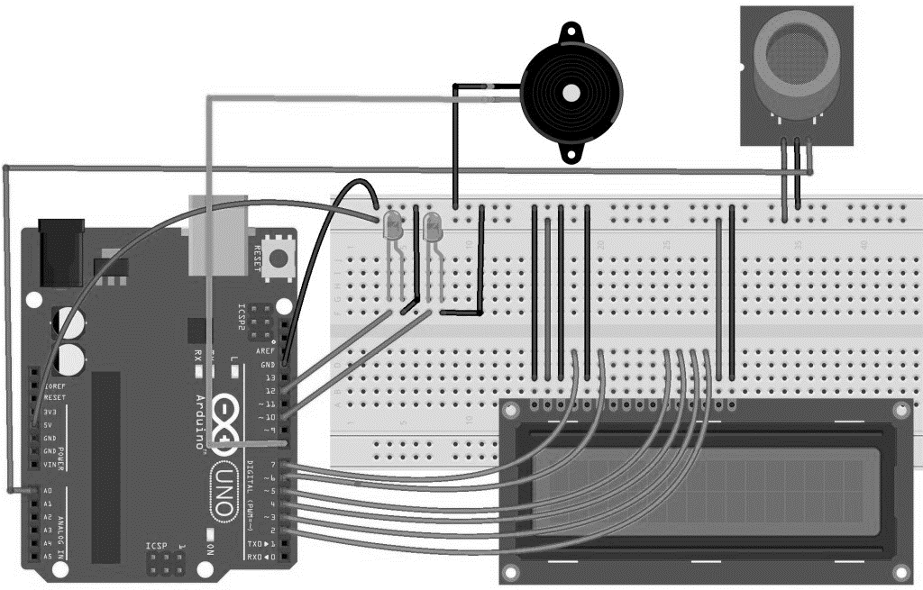

**Fig 2.2 Circuit Diagram Of Food Quality Monitoring System**

**2.2 COMONENT DISCRITION**

The following component are employed in the proposed circuit design

* LCD (Liquid crystal display)
* MQ-315 SENSOR
* MQ-2 SENSOR
* ARDUINO UNO
* BUZZER

The components employed in the proposed explained as follows

|  |  |
| --- | --- |
| **2.2.1** | **LCD (Liquid Crystal Display)** |

Type of flat panel display which uses liquid crystals in its primary form of operation.

LEDs have a large and varying set of use cases for consumers and businesses, as they can be commonly found in smartphones, televisions, computer monitors and instrument panels.

4

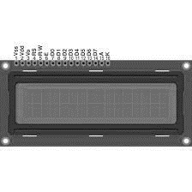

**Fig 2.3 LCD Display**

An LCD panel is made of many layers. These consist of a polariser, polarised glass, LCD fluid, conductive connections etc. Polarizations is a process in which the vibration of light waves is restricted to a single plane, resulting in the formation of light waves known as polarized light. Since liquid crystals do not produce light of their own, they need an external light source to work. An LCD panel has sets of polarized glass consisting of liquid crystal materials

in between them. When the external light passes through one of the polarized

glasses and electric current is applied on the liquid crystal molecules, they align themselves in such a way that polarized light travels from the first layer to the second polarized glass, causing an image to appear on the screen.

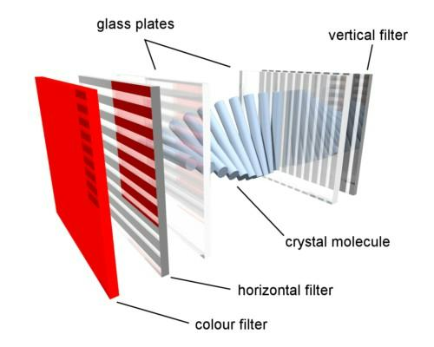

**Fig 2.4 Layers of LCD**

5

*Specifications of LCD 16X2*

* The operating voltage of this display ranges from 4.7V to 5.3V
* The display bezel is 72 x 25mm
* The operating current is 1mA without a backlight
* PCB size of the module is 80L x 36W x 10H mm
* HD47780 controller
* LED colour for backlight is green or blue
* Number of columns – 16
* Number of rows – 2
* Number of LCD pins – 16
* Characters – 32
* It works in 4-bit and 8-bit modes
* Pixel box of each character is 5×8 pixel
* Font size of character is 0.125Width x 0.200height *Advantages of LED*
* Slim Design
* Brighter and sharper Images
* Flicker-Free Images
* Better Picture Quality (true black picture)
* No motion delay and lags
* Longer lifespan and less environmental impact
* Lower Power Consumption
* Wider Viewing angle (typically 175 degree) *Disadvantages of LED*
* LEDs are more expensive than conventional lighting technologies
* LEDs can shift colour due to age and temperature
* LED is a lot thinner than the LCD or Plasma.
* Contrast ratios not consistent

6

**Table 2.1 Sensor and the corresponding sensing gas**

|  |  |
| --- | --- |
| **Sensor** | **Sensing gas** |
| MQ-2 | Methane, Butane, LPG, Smoke |
| MQ-3 | Alcohol, Ethanol, Smoke |
| MQ-4 | Methane, CNG gas |
| MQ-5 | Natural gas, LPG |
| MQ-6 | LPG, Butane |
| MQ-8 | Hydrogen gas |
| MQ-9 | Carbon monoxide, Flammable gasses |
| MQ135 | Air quality , Ammonia |
| MQ136 | Hydrogen sulfide gas |

**2.2.2 MQ-135 Air Quality Gas Sensor Module**

The MQ-135 Gas sensor can detect gases like Ammonia (NH3), sulfur (S), Benzene (C6H6), CO2, and other harmful gases and smoke. Similar to other MQ series gas sensor, this sensor also has a digital and analog output pin. When the level of these gases go beyond a threshold limit in the air the digital pin goes high. This threshold value can be set by using the on-board potentiometer. The analog output pin, outputs an analog voltage which can be used to approximate the level of these gases in the atmosphere .The MQ135 air quality sensor module operates at 5V and consumes around 150mA. It requires some pre-heating before it could actually give accurate results.

|  |  |
| --- | --- |
| **Details** | **of MQ135 Sensor** |
|  | The MQ135 is one of the popular gas sensors from the MQ series of sensors that are |

commonly used in air quality control equipment. It operates from 2.5V to 5.0V and can provide both digital and analog output. The pinouts and important components on an MQ135

Module.

7

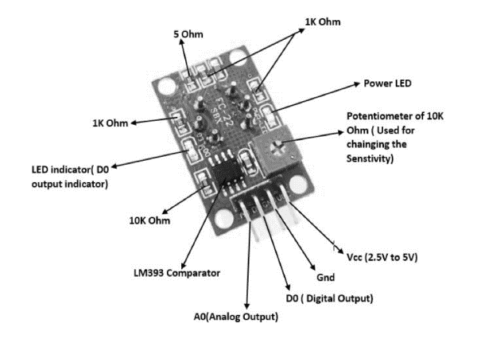

**Fig 2.5 MQ-315 Sensor**

Note that all MQ sensors have to be powered up for a pre-heat duration for the sensor to warm up before it can start working. This pre-heat time is normally between 30 seconds to a couple of minutes. When you power up the module the power LED will turn on, leave the module in this state till the pre-heat duration is completed.

*Detect Harmful Gases using Digital Pin*

The digital output pin of the sensor can be used to detect harmful gases in the environment. The sensitivity of the digital pin can be controlled by using the 10k potentiometer. If the gas is detected the indicator LED D0 will turn on and the digital pin will go from logic high to logic low (0V). The LM393 Op-Amp Comparator IC is used to compare the actual gas value with the value set using the potentiometer. If the actual gas value increases than the set value then the digital output pin gets low. Because of the onboard

LM393 comparator IC the MQ135 Gas sensor module can also be used without the need of an external microcontroller. Simply power up the module and set the sensitivity of the digital pin using the potentiometer, then when the module detects the gas the digital pin will go low.

|  |  |
| --- | --- |
| This | digital pin can directly be used to drive a buzzer or LED with the help of simple |
| transistors. | |

8

*Measure PPM Value using Analog Pin*

The Analog output pin of the sensor can be used to measure the PPM value of the required gas. To do this we need to use an external microcontroller like Arduino. The microcontroller will measure the value of analog voltage and perform some calculations to find the value of Rs/Ro where Rs is the sensor resistance when gas is present and Ro is sensor resistance at clean air. Once we find this ratio of Rs/Ro we can use it to calculate the PPM value of required gas using the graph below which is taken from the datasheet of MQ135 sensor. If you are just detecting the gas and not measuring the PPM then the module need not be calibrated or pre-heated and hence it is extremely simple to use. You can find these MQ

Gas sensors commonly used in Gas/Smoke detectors and Air Quality Monitors. The dimensions of the MQ135 Gas sensor module is given below

*Technical Specifications of MQ135 Gas Sensor*

* Operating Voltage: 2.5V to 5.0V
* Power consumption: 150mA
* Detect/Measure: NH3, Nox,CO2, Alcohol, Benzene, Smoke, Ammonia.
* Typical operating Voltage: 5V

**2.2.3 MQ2 Gas Sensor**

This hydrogen, methane, and carbon monoxide is a robust Gas sensor suitable for sensing LPG ,Smoke ,Alcohol ,propane, hydrogen, methane, and carbon monoxidehydrogen, methane, and carbon monoxide concentrations in the air. If you are planning on creating an indoor air quality monitoring system; breath checker or early fire detection system, MQ2 Gas Sensor Module is a great choice. MQ2 Gas sensor works on 5V DC and draws around 800mW. It can detect LPG, Smoke, Alcohol, Propane, Hydrogen, Methane and Carbon Monoxide concentrations anywhere from 200 to 10000ppm.The sensor is actually enclosed in two layers of fine stain less steel mesh called Anti-explosion network. It ensures that heater element inside the sensor will not cause an explosion, as we are sensing flammable gases.

It also provides protection for the sensor and filters out suspended particles so that only gaseous elements are able to pass inside the chamber. The mesh is bound to rest of the body via a copper plated clamping ring. This is how the sensor looks like when outer mesh is

9

removed. The star-shaped structure is formed by the sensing element and six connecting legs that extend beyond the Bakelite base.

|  |  |
| --- | --- |
|  |  |

**Fig 2.6 MQ Sensor**

Out of six, two leads (H) are responsible for heating the sensing element and are connected through Nickel-Chromium coil, well known conductive alloy. The remaining four leads (A & B) responsible for output signals are connected using Platinum Wires. These wires are connected to the body of the sensing element and convey small changes in the current that passes through the sensing element.

**2.2 Table MQ 2 Specifications**

|  |  |
| --- | --- |
| **PARAMETER** | **RANGE** |
| Operating voltage | 5V |
| Load resistance | 20 KΩ |
| Heater resistance | 33Ω ± 5% |
| Heating consumption | <800mw |
| Sensing Resistance | 10 KΩ – 60 KΩ |
| Concentration Scope | 200 – 10000ppm |
| Preheat Time | Over 24 hour |

10

Connecting the MQ2 Gas sensor module to the Arduino is pretty easy. Start by placing the sensor on to your breadboard. Connect VCC pin to the 5V pin on the Arduino and connect

GND pin to the Ground pin on the Arduino.

**Applications**

These sensors are used to detect the presence of gases in the air such as methane, butane, LPG and smoke but they are unable to distinguish between gases. Thus, they cannot tell which gas it

is. Module version of this sensor can be used without interfacing to any

microcontroller and is useful when detecting only one particular gas.

**2.2.4 Arduino UNO**

**Arduino UNO** an microcontroller development board based on eight bit ATmega328 microcontroller. Along with ATmega328P MCU IC, it consists other components such as crystal oscillator, serial communication, voltage regulator, etc. to support the microcontroller

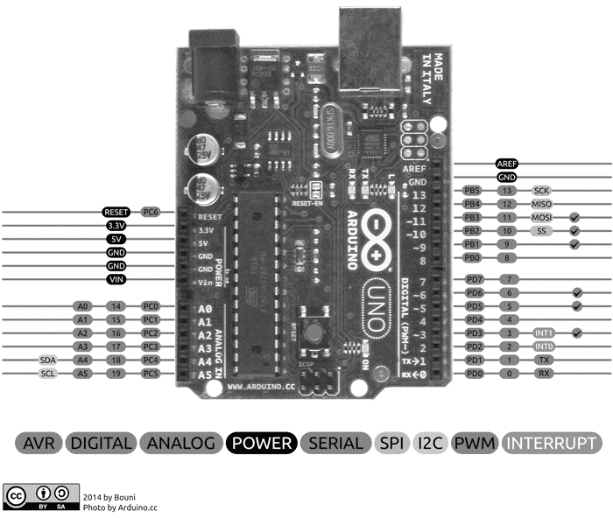

**Fig 2.7 Arduino Uno**

11

***Arduino part specifications***

Power USB: Arduino board can be powered by using the USB cable from your computer. All you need to do is connect the USB cable to the USB connection

|  |  |
| --- | --- |
| Voltage Regulator | : The function of the voltage regulator is to control the voltage given to the |
| Arduino board and stabilize the DC voltages used by the processor and other elements. | |

|  |  |
| --- | --- |
| Arduino Reset | : You can reset your Arduino board, i.e., start your program from the |

beginning. You can reset the UNO board in two ways. First, by using the reset button on the board. Second, you can connect an external reset button to the Arduino pin labelled RESET .

|  |  |
| --- | --- |
| Analog pins : | Arduino UNO board has six analogy input pins A0 through A5. These pins can |

read the signal from an analogy sensor like the humidity sensor or temperature sensor and convert it into a digital value that can be read by the microprocessor.

|  |  |
| --- | --- |
| TX and RX LEDs | **:** On your board, you will find two labels: TX (transmit) and RX |

(receive). They appear in two places on the Arduino UNO board. First, at the digital pins 0 and 1, to indicate the pins responsible for serial communication. Second, the TX and RX led

(13). The TX led flashes with different speed while sending the serial data. The speed of flashing depends on the baud rate used by the board. RX flashes during the receiving process.

|  |  |
| --- | --- |
| Digital I/O | **:**The Arduino UNO board has 14 digital I/O pins (15) (of which 6 provide PWM |

(Pulse Width Modulation) output. These pins can be configured to work as input digital pins to read logic values (0 or 1) or as digital output pins to drive different modules like LEDs, relays, etc. The pins labelled can be used to generate PWM.

|  |  |  |
| --- | --- | --- |
| AAREF | **:** AREF stands for Analog Reference. It | is sometimes, used to set an external |
| reference voltage (between 0 and 5 Volts) as the upper limit for the analogy input pins. | | |

|  |  |
| --- | --- |
| Main microcontroller | **:** Each Arduino board has its own microcontroller . You can assume it |

as the brain of your board. The main IC (integrated circuit) on the Arduino is slightly different from board to board. The microcontrollers are usually of the ATMEL Company.

You must know what IC your board has before loading up a new program from the Arduino

12

IDE. This information is available on the top of the IC. For more details about the IC construction and functions, you can refer to the data sheet.

|  |  |
| --- | --- |
| Communication | **:** The Arduino Uno ATmega328 offers UART TTL-serial communication, |

and it is accessible on digital pins like TX (1) and RX (0). The software of an Arduino has a serial monitor that permits easy data. There are two LEDs on the board like RX & TX which will blink whenever data is being broadcasted through the USB. A Software Serial library permits for serial communication on Arduino Uno digital pins and the ATmega328P supports

TWI (I2C) as well as SPI-communication. The Arduino software contains a wired library for simplifying the utilization of the I2C bus.

|  |  |
| --- | --- |
| Power LED indicator | **:** This LED should light up when you plug your Arduino into a power |

source to indicate that your board is powered up correctly. If this light does not turn on, then there is something wrong with the connection.

**Table 2.3 Arduino Uno Technical Specifications**

|  |  |  |
| --- | --- | --- |
| **Component** | **Range** | |
| Microcontroller | | ATmega328P – 8 bit AVR family microcontroller |

|  |  |
| --- | --- |
| Operating Voltage | 5V |
| Recommended Input Voltage | 7-12V |
| Input Voltage Limits | 6-20V |
| Analog Input Pins | 6 (A0 – A5) |
| Digital I/O Pins | 14 (Out of which 6 provide PWM output) |
| DC Current on I/O Pins | 40 Ma |
| DC Current on 3.3V Pin | 50 Ma |

**Advantages of ARDUINO UNO**

* Inexpensive
* Open source in hardware

13

* Don’t need to external programmer (Burner)
* Programming ease
* Open source in software
* IDE Software operate on any operating system

|  |  |  |
| --- | --- | --- |
| **2.2.5** | **BUZZER** | |
|  | | An audio signaling device like a beeper or buzzer may be electromechanical or | |

piezoelectric or mechanical type. The main function of this is to convert the signal from audio to sound. Generally, it is powered through DC voltage and used in timers, alarm devices, printers, alarms, computers, etc. Based on the various designs, it can generate different sounds like alarm, music, bell & siren. The pin configuration of the buzzer is shown below. It includes two pins namely positive and negative. The positive terminal of this is represented with the ‘+’ symbol or a longer terminal. This terminal is powered through

6Volts whereas the negative terminal is represented with the ‘-‘ symbol or short terminal and it is connected to the GND terminal. Show in Fig 2.9

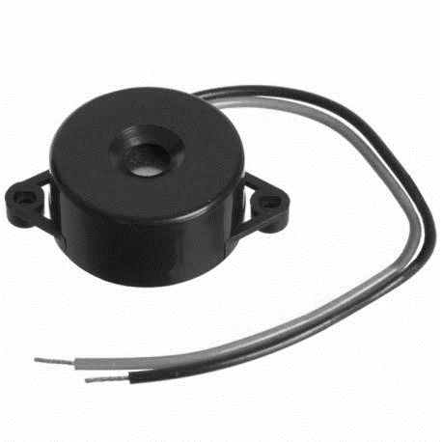

**Fig 2.8 Buzzer**

The buzzer is a sounding device that can convert audio signals into sound signals. It is usually powered by DC voltage. It is widely used in alarms, computers, printers and other electronic products as sound devices. It is mainly divided into piezoelectric buzzer and electromagnetic buzzer, represented by the letter "H" or "HA" in the circuit. According to different designs and uses, the buzzer can emit various sounds such as music, siren, buzzer,

14

alarm, and electric bell.

|  |  |
| --- | --- |
| Specifications | **:** |

* The specifications of the buzzer include the following.
* Color is black
* The frequency range is 3,300Hz
* Operating Temperature ranges from – 20° C to +60°C
* Operating voltage ranges from 3V to 24V DC
* The sound pressure level is 85dBA or 10cm
* The supply current is below 15mA

|  |  |
| --- | --- |
| Advantages | **:** |

* Simply Compatible
* Frequency Response is Good
* Size is small
* Energy Consumption is less
* The Range of Voltage usage is Large

|  |  |
| --- | --- |
| Disadvantages | **:** |

* Controlling is a little hard
* Generates Annoying Sound
* Training is necessary to know how to repair the condition without just turning off.

15

**CHAPTER 3**

**IMPLEMENTATION DETAILS /ARDUNIO UNO CODING**

|  |  |  |
| --- | --- | --- |
| **3.1** | | **ARDUINO IDE SOFTWARE** |
|  |  | | |

The Arduino Intergrated Development Environment –or Arduino Software (IDE) contains a text editor for writing code, a message area, a text console, a toolbar with buttons for common functions and a series of menus. It connects to the Arduino hardware to upload programs and communicate with them.

**Step 1**

Open the LED blink example sketch:

File>Examples>01.Basics>Blin

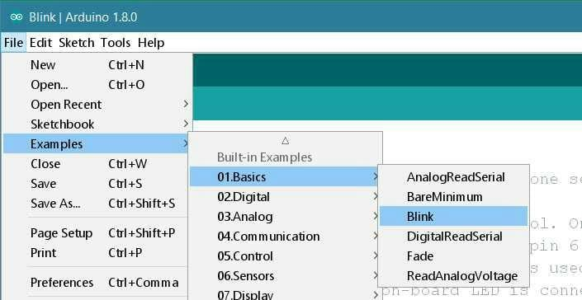

**Fig 3.1 Led Blink**

**Step 2**

You'll need to select the entry in the Tools > Board menu that corresponds to your

Arduino board UNO

16

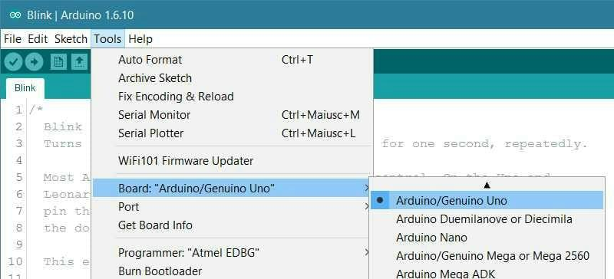

**Fig 3.2 Board Arduino UNO**

**Step 3**

Select the serial device of the board from the Tools | Serial Port menu. This is likely to be

COM3 or higher (COM1 and COM2 are usually reserved for hardware serial ports). To find out, you can disconnect your board and re-open the menu; the entry that disappears should be the Arduino board. Reconnect the board and select that serial port.

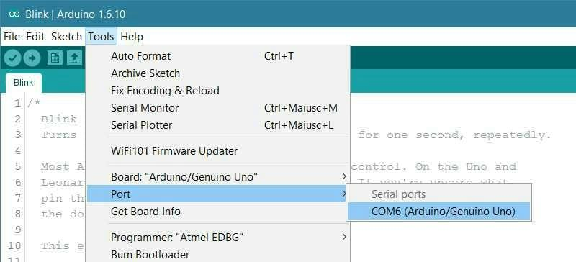

**Fig 3.3 COM6(Arduino UNO)**

**Step 4**

|  |  |
| --- | --- |
| **Upload the program** | : Now, simply click the "Upload" button in the environment. Wait a |

few seconds - you should see the RX and TX leds on the board flashing. If the upload is successful, the message "Done uploading." will appear in the status bar.

17

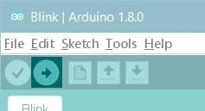

**Fig 3.4 Upload The Program**

A few seconds after the upload finishes, you should see the pin 13 (L) LED on the board start to blink (in orange). If it does, congratulations! You've gotten Arduino up-and- running. If you have problems, please see the troubleshooting suggestions.

**3.2 ARDUNINO UNO BOARD MICROCONTROLLER**

Int red led=11,int green led=12,int buzzer=13 is indicated in digital output pins in Arduino board.A1,A2 are 2 analog input in Arduino board. PINMODE is function has been indicted in input and outputs .Lcd print function is what are the letters are printed in lcd displayed in that function .This function bare in side in void setup. Next we are seen in void loop. This void loop inside small c programming function of else if concept are used. First if condition are true are false compiler is check and true means that print function can be what are you type that in print. But if condition is false compiler go to else condition else condition are true means that printf function what are you print in that is printed in display.

**3.3 ARDUNINO UNO CODING**

#include <LiquidCrystal.h>

LiquidCrystallcd(7, 6, 5, 4, 3, 2);

intredled=11;

intgreenled=12;

int buzzer=13;

int smokeA0=A1;

int smokeA1=A2;

intsensorThres=400;

void setup()

18

{

pinMode(redled,OUTPUT); pinMode(greenled,OUTPUT); pinMode(buzzer,OUTPUT); pinMode(smokeA0,INPUT); pinMode(smokeA1,INPUT); lcd.begin(16,2);

lcd.print("any one print"); lcd.setCursor(0,1);

lcd.print("Circuit Digest"); delay(2000);

Serial.begin(9600);

}

void loop()

{

intanalogsensor=analogRead(smokeA0); int analogsensor1=analogRead(smokeA1);

Serial.print("pinA0:");

Serial.print("pinA1:");

Serial.println(analogsensor);

Serial.println(analogsensor1);

{

if(analogsensor>= 400)

{

digitalWrite(redled,HIGH); lcd.setCursor(0,2);

lcd.print("food is not good"); digitalWrite(greenled,LOW);

tone(buzzer,1000,200);

19

}

else

{

digitalWrite(redled,LOW); lcd.setCursor(0,2);

lcd.print("food is good"); digitalWrite(greenled,HIGH); noTone(buzzer);

{

if(analogsensor1>= 400)

{

digitalWrite(redled,HIGH); lcd.setCursor(0,1);

lcd.print("food is not good"); digitalWrite(greenled,LOW);

tone(buzzer,1000,200);

}

else

{

digitalWrite(redled,LOW); lcd.setCursor(0,1);

lcd.print("food is good"); digitalWrite(greenled,HIGH); noTone(buzzer);

}

}

delay(500);

lcd.clear();

20

**CHAPTER 4**

**WORKING AND HARDWARE**

|  |  |
| --- | --- |
| **4.1** | **WORKING PROCEDURE OF THE PROJECT** |
|  | The working procedure of the food quality monitoring system using Arduino UNO | |

circuit Is presented as follows

Step 1: MQ 135 Sensor sense the ammonia and the signal is passed to the Arduino board.

Before sensing the ammonia the voltage will be low after voltage sensing it will be changed into high.

Step 2 :MQ 2 Sensor sense the methane and the signal is passed to the Arduino board.methane and the Signal.

Before sensing the methane the voltage will be low after voltage sensing it will be changed into high.

Step 3: E Nose sense the food decaying levels are varies gas level (Methane, Ammonia), the Arduino is programmed to identify the varying levels of the produced gas based on that the quality of the food is identified.

Step 4: If the quality of the food is good then the status will be displayed in LCD as Good Quality and also indicated by green led. If the quality of the food is not good then the status will be displayed in LCD as Bad Quality and also indicated by Red led.

|  |  |
| --- | --- |
|  |  |
|  |

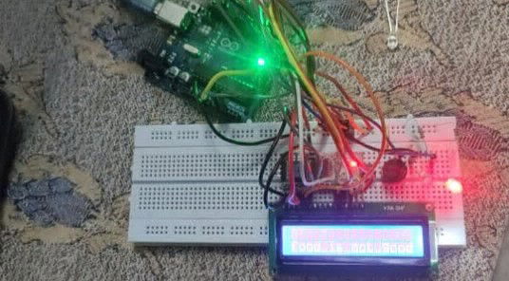

**Fig 4.1 Hardware Kit Food Quality Monitoring System Using Arduino UNO**

21

**CHAPTER 5**

**CONCLUSION AND FUTURE WORK**

* 1. **CONCLUSION**

The early detection of the gases from different food items like ammonia, methane etc. can help the gas sensor are able to detect gas emission from food items even before the presence of any visible sign of spoilage. The consumer gets the information about the food item wherein he can monitor the perish ability of that food item. This will help in maintenance of health and prevents the consumer from consuming bad food. The use of technology helps in food processing industry wherein they can mention the duration of perish ability of the food item on the packet so that proper control on consumption can be done. The monitoring and detection of the food items is very necessary as most of the consumers buy packed food from the malls wherein date of expiry is important parameter

* 1. **FUTURE WORK**

The Arduino UNO controller is used to identify the quality of food and send the information to Cloud computing and artificial intelligence techniques can be employed to classify the quality of the food effectively.

22

**REFERENCES**

1. [Mike](https://www.google.com/search?cs=0&q=Mike+Cheich&stick=H4sIAAAAAAAAAOPgE-LVT9c3NCwqNiwpsSwzUYJwCy1KsrLTy5K0ZLKTrfST8vOz9cuLMktKUvPiy_OLsq0SS0sy8osWsXL7ZmanKjhnpGYmZ-xgZdzFzsTBAAAh_wD3VAAAAA&sa=X&ved=2ahUKEwi9keyrnJP4AhWW3jgGHZV-BgoQmxMoAXoECFcQAw) [Cheich](https://www.google.com/search?cs=0&q=Mike+Cheich&stick=H4sIAAAAAAAAAOPgE-LVT9c3NCwqNiwpsSwzUYJwCy1KsrLTy5K0ZLKTrfST8vOz9cuLMktKUvPiy_OLsq0SS0sy8osWsXL7ZmanKjhnpGYmZ-xgZdzFzsTBAAAh_wD3VAAAAA&sa=X&ved=2ahUKEwi9keyrnJP4AhWW3jgGHZV-BgoQmxMoAXoECFcQAw), “Arduino Book for Beginners” July 2021.

2. Sudhakar/shyammohan, “Electric Circuit Analysis” Tata McGraw-Hill Education, 01-Dec-

2006.

3. Electronics Fundamentals Circuits Devices and Applications 8th Edition By David M

Buchla and Thomas L Floyd.

23